The electric car charging market

There are many different charging methods, each taking different amounts of time and requiring different initial investments. At the moment there is a large amount of companies that have installed charging points for electric cars.

Also different countries have different standard plugs for different charging methods. There are however, many initiatives at the moment by organizations such as the EU to standardize these plugs.

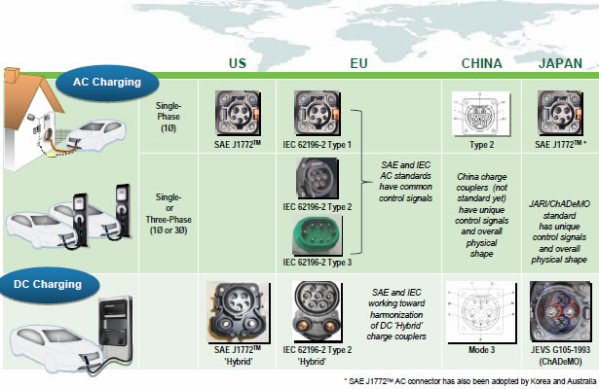

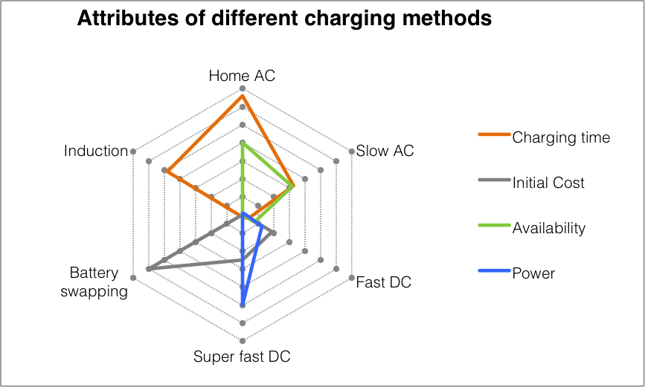

These can mainly be divided into 3 different categories: Electric car manufacturers, Electricity companies and Electric car charging companies.

As the set-up of an electric car charging network requires a very high initial investment, it is a relatively risky business to get into. Since the beginning of the modern electric car era, there have been several large charging companies that have had to apply for bankruptcy, the most famous probably being Ecotality in the USA. The bankruptcies were mainly due to wrong management and investment strategies.

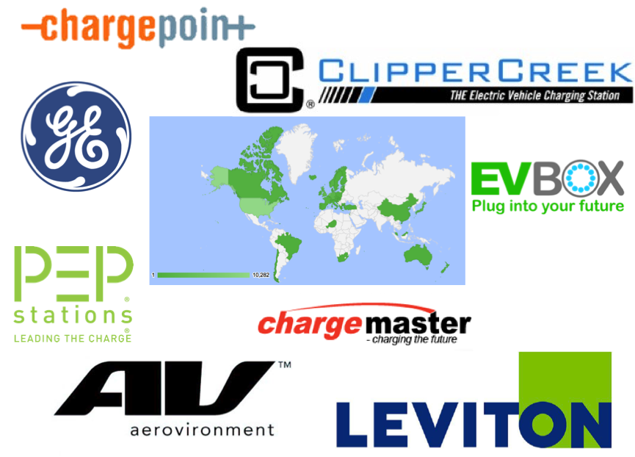As electric car owners will always need to be able to charge their car at home, or at it’s main parking place, many electric car manufacturers, such as Tesla, Opel Ampera and Nissan Leaf offer the opportunity to purchase a home charging point with the purchase of a new vehicle. Nissan Leaf even requires this, as it has a special type of charging station, although it also gives to possibility of a waiver if the new owner has a compatible charging point installed by a third party.

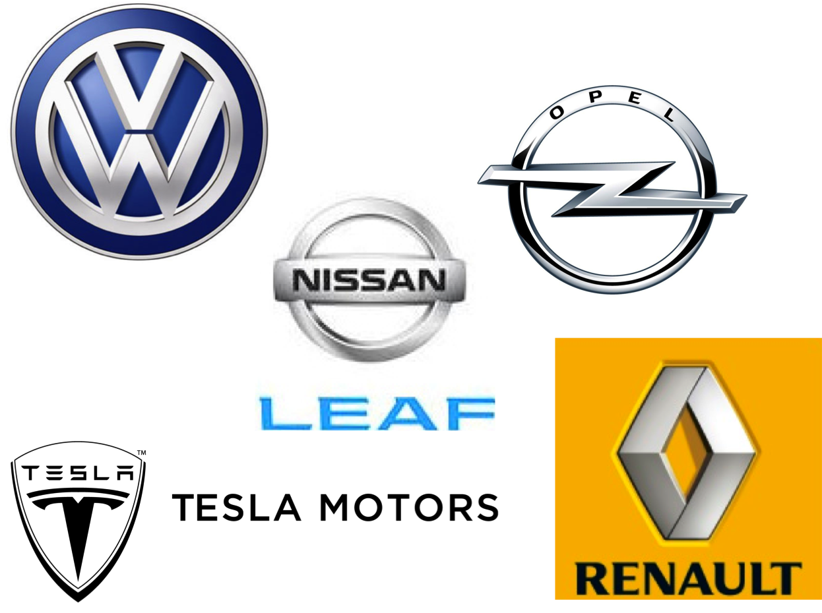

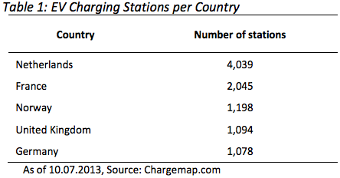

One of the main problems for the users in the car charging market is the diversity of charging networks. Due to lack of collaboration and membership requirements, companies try to limit users to use only their chargers. As customers are mostly required to use multiple companies due to logistic reasons, they need (sometimes prepaid) memberships to multiple suppliers. This leads to an overload of cards and paperwork for the user. Standardization of payments systems or collaboration between companies could solve these issues.

